Lab: Working with Files
Goal: Show the most basic way to upload and download files

Download a file
In this section we’ll cover how to return a file from an ASP.NET Core Web API.
As a demo, we’re downloading a file that is added as content to our project.
In real-world scenarios, you’ll more probably get file streams from a database or BLOB storage.
Steps:
- Add a pdf file to our project, by dragging it into the Solution Explorer onto the project
- Right click the pdf file in the Solution Explorer and select “Properties”
- Set “Copy to output directory” to “Always”
- Add a new Controller named “FilesController” in the “Controllers” folder
[ApiController]
[Route("files")]
public class FilesController: ControllerBase
{
}
- Add the GetFile method, which returns our PDF with the name we pass as a query string parameter
[HttpGet]
public async Task<IActionResult> GetFile(string fileName)
{
var filePath = "Core principles.pdf";

if (string.IsNullOrWhiteSpace(fileName))
{
return BadRequest();
}

if (!System.IO.File.Exists(filePath))
{
return NotFound();
}

var fileBytes = await System.IO.File.ReadAllBytesAsync(filePath);

return File(fileBytes, "application/pdf", fileName);
}
- Run the application (F5) and use a browser to navigate to https://localhost:7043/files?fileName=test.pdf, verify that the PDF downloads successfully and that you’re able to open it
Our current implementation has the content type “application/pdf” hard coded. This would mean that other file types (e.g. Word documents) would not open properly after downloading.
Luckily we can retrieve the content type from our file and pass that along with the File result, instead of the hard coded value.
- In our program.cs file, let’s register FileExtensionContentTypeProvider service to our DI container
Notice we use a Singleton lifetime as this is a utility class for which the instance can be used cross request
Don’t forget to add a using statement for Microsoft.AspNetCore.StaticFiles;
var builder = WebApplication.CreateBuilder(args);

builder.Services.AddDbContext<PieShopDbContext>(options =>
options.UseInMemoryDatabase("PieShopDb")
.LogTo(Console.WriteLine));

builder.Services.AddScoped(typeof(IPieRepository), typeof(PieRepository));

builder.Services.AddSingleton(new FileExtensionContentTypeProvider());

builder.Services.AddControllers();
// ...
- Inject the FileTypeProvider in our FileController’s constructor
[ApiController]
[Route("files")]
public class FilesController: ControllerBase
{
private readonly FileExtensionContentTypeProvider _contentTypeProvider;

public FilesController(FileExtensionContentTypeProvider contentTypeProvider)
{
_contentTypeProvider = contentTypeProvider;
}
//...
}
- Change the GetFile method to use the derived content type.
Use “application/octet-stream” as a fallback: this generic content type for binary data
[HttpGet]
public async Task<IActionResult> GetFile(string fileName)
{
var filePath = "Core principles.pdf";

if (string.IsNullOrWhiteSpace(fileName))
{
return BadRequest();
}

if (!System.IO.File.Exists(filePath))
{
return NotFound();
}

if (!_contentTypeProvider.TryGetContentType(filePath, out var contentType))
{
contentType = "application/octet-stream";
}

var fileBytes = await System.IO.File.ReadAllBytesAsync(filePath);

return File(fileBytes, contentType, fileName);
}
- Run the application (F5) and use a browser to navigate to https://localhost:7043/files?fileName=test.pdf to verify everything still works
- Test by adding another file type e.g. powerpoint presentation and verify if that can be downloaded as well
  - Repeat steps 1 to 3 with a different file
  - Change the value of the filePath variable in the GetFile method

Upload a file
In this part we’ll implement uploading files to our API.
As an example, we save the uploaded file to the project directory of our application.
! Don’t do this in real-life scenarios ! you don’t want your application server to crash because of a full disk

Steps:
- Add the CreateFile method to our FilesController
Notice we’re checking if we didn’t receive an empty file and that the filesize is less than 50 MB
[HttpPost]
public async Task<IActionResult> CreateFile(string fileName, IFormFile file)
{
if (string.IsNullOrWhiteSpace(fileName) || file.Length == 0 || file.Length > 52428800)
return BadRequest();

// don't do this in real projects!!!
var filePath = Path.Combine(Directory.GetCurrentDirectory(), $"{Guid.NewGuid()}-{fileName}");

using (var stream = new FileStream(filePath, FileMode.Create))
{
await file.CopyToAsync(stream);
}

return Created();
}
- Launch the application (F5) and use Postman to test
  - Create a new POST request to https://localhost:7043/files
  - Add the filename query string parameter
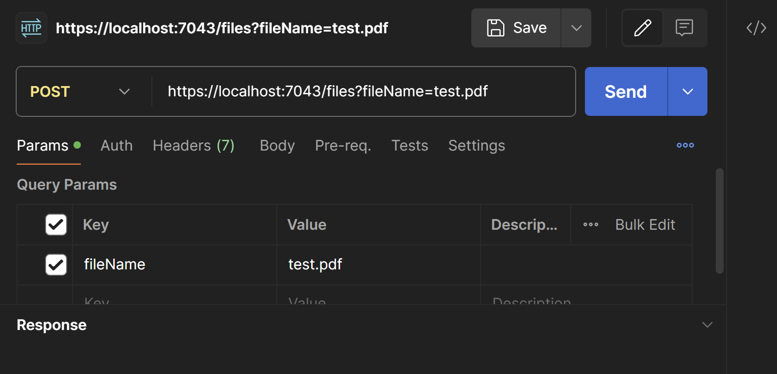
  - In the Body tab, change the content type to “form-data”, add a new field called “file” and change the dropdown to “File” and select a local file
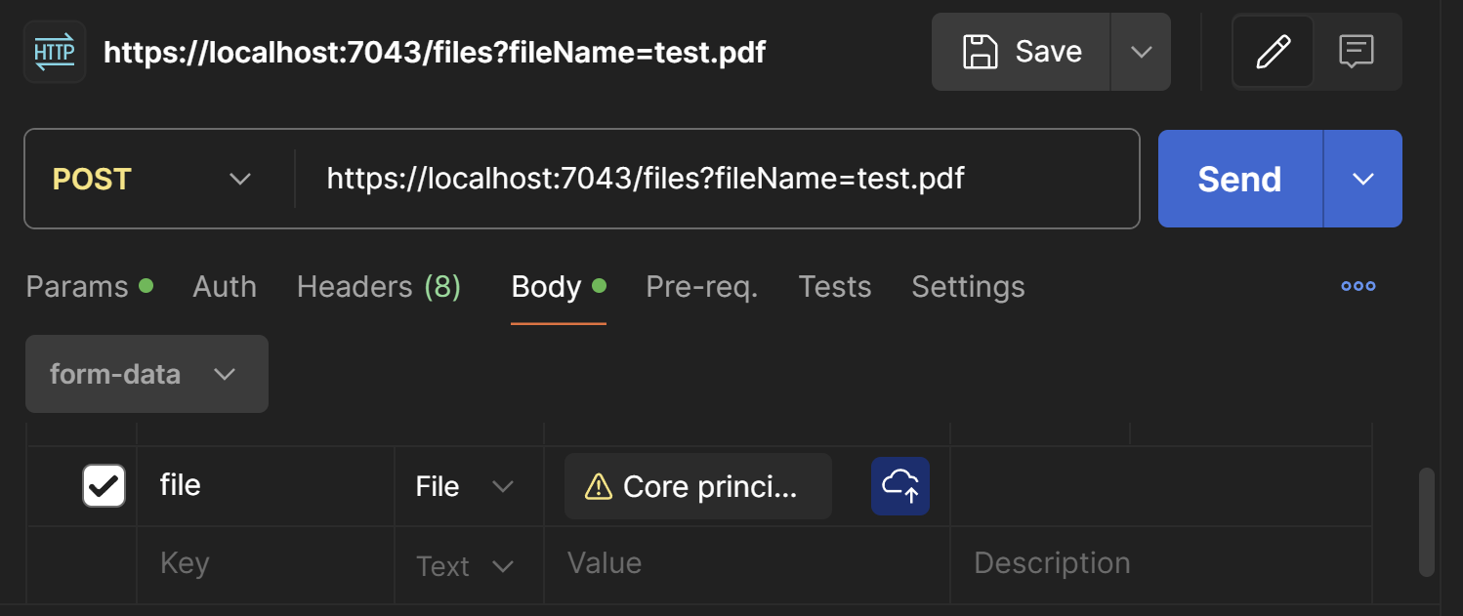
  - Click send and verify a 204-No Content status code is returned.
Also a file should have been added to your project with the provided filename, prefixed with a GUID

